Cuza -

The Life-Sized 3D Printed Remote-Control Humanoid Robot

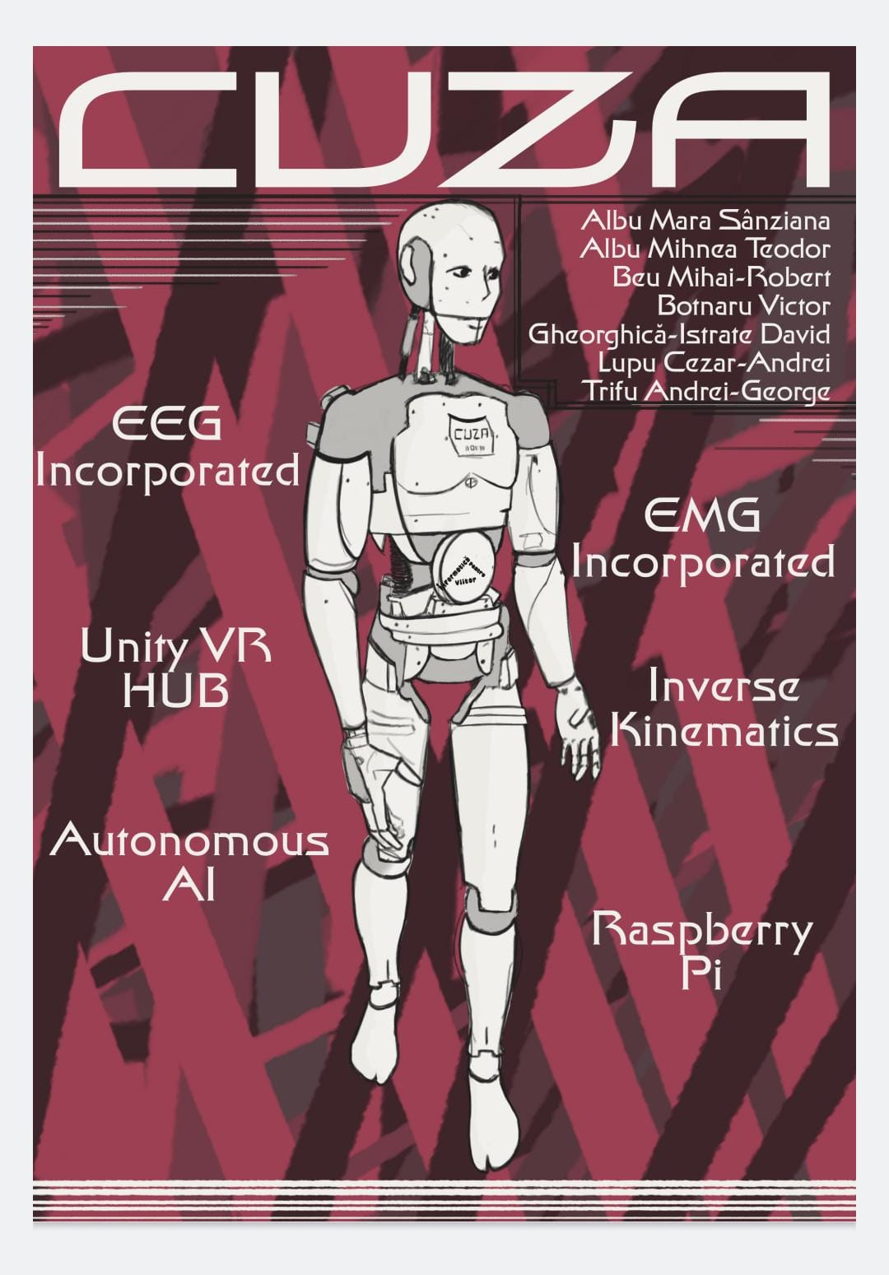

# Brief

Cuza is the name of our robot friend, developed over the summer, and composed almost entirely of 3D printed parts, based on the open-source InMoov model developed by Gaël Langevin. Cuza presents as a multi-purpose humanoid assistant, with the functionality of detecting human emotion,translating languages of a conversation, and AI - powered verbal chatting. The robot can be controlled using a VR headset and an EMG sensor for the arms, and an EEG brain band and a mobile application for the bottom.

## Aim of the project

Cuza aims the be the following:

* An innovative approach to remote robotic control, combining the technologic fields of Virtual Reality, Electroencephalography and Electromyography.
* A powerful AI-based assistant with home and industrial applications.

## Why Cuza? - Examples

* Electromyographic and Electroencephalographic controls enable the humanoid to work as a home assistant for the physically impaired.
* Acting as a translator, Cuza can be employed in the center of an international institute for easy communication.
* The PLA-based components make Cuza a cheap and effective alternative to manual industrial labor.
* AI Chat integration makes the humanoid a smart-home assistant that can perform diverse chores and quickly answer questions.
* VR Control marks Cuza as an engine for exploring areas otherwise dangerous to humans, such as those with high radiation or non-breathable air.

# Technologies Used

The following modules were used for controlling and programming Cuza:

# Mechanical Part

## Humanoid

The skeleton of Cuza is almost fully 3D printed, with a nozzle size of 0.4. GCODEs were compiled with PrusaSlicer, and .stl -s files were provided by the hosting website inmoov.fr. The operation was conducted with the help of six different 3D-printers:

* Prusa MK3S
* Creality Ender-3
* Creality Ender-3v2
* Creality CR6
* Creality Ender-3 Pro
* Creality Ender-3 Neo

The elbows, shoulders, neck and are connected with worm joints, the head rotation is based on a gear joint, and the eyes are directly connected to servomotors.

Below are the open-source diagrams used for building the model: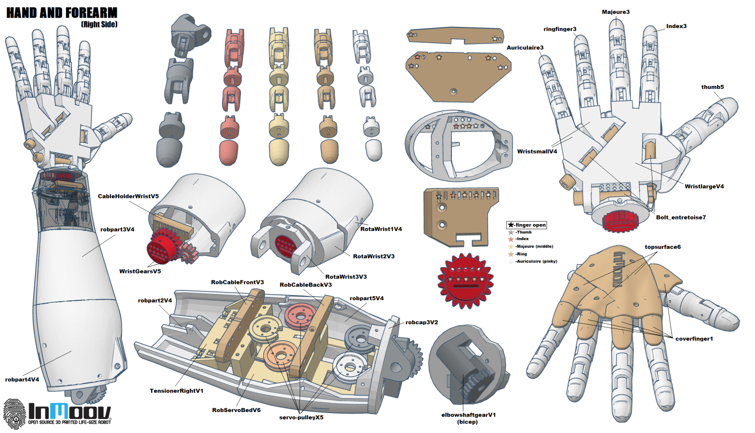

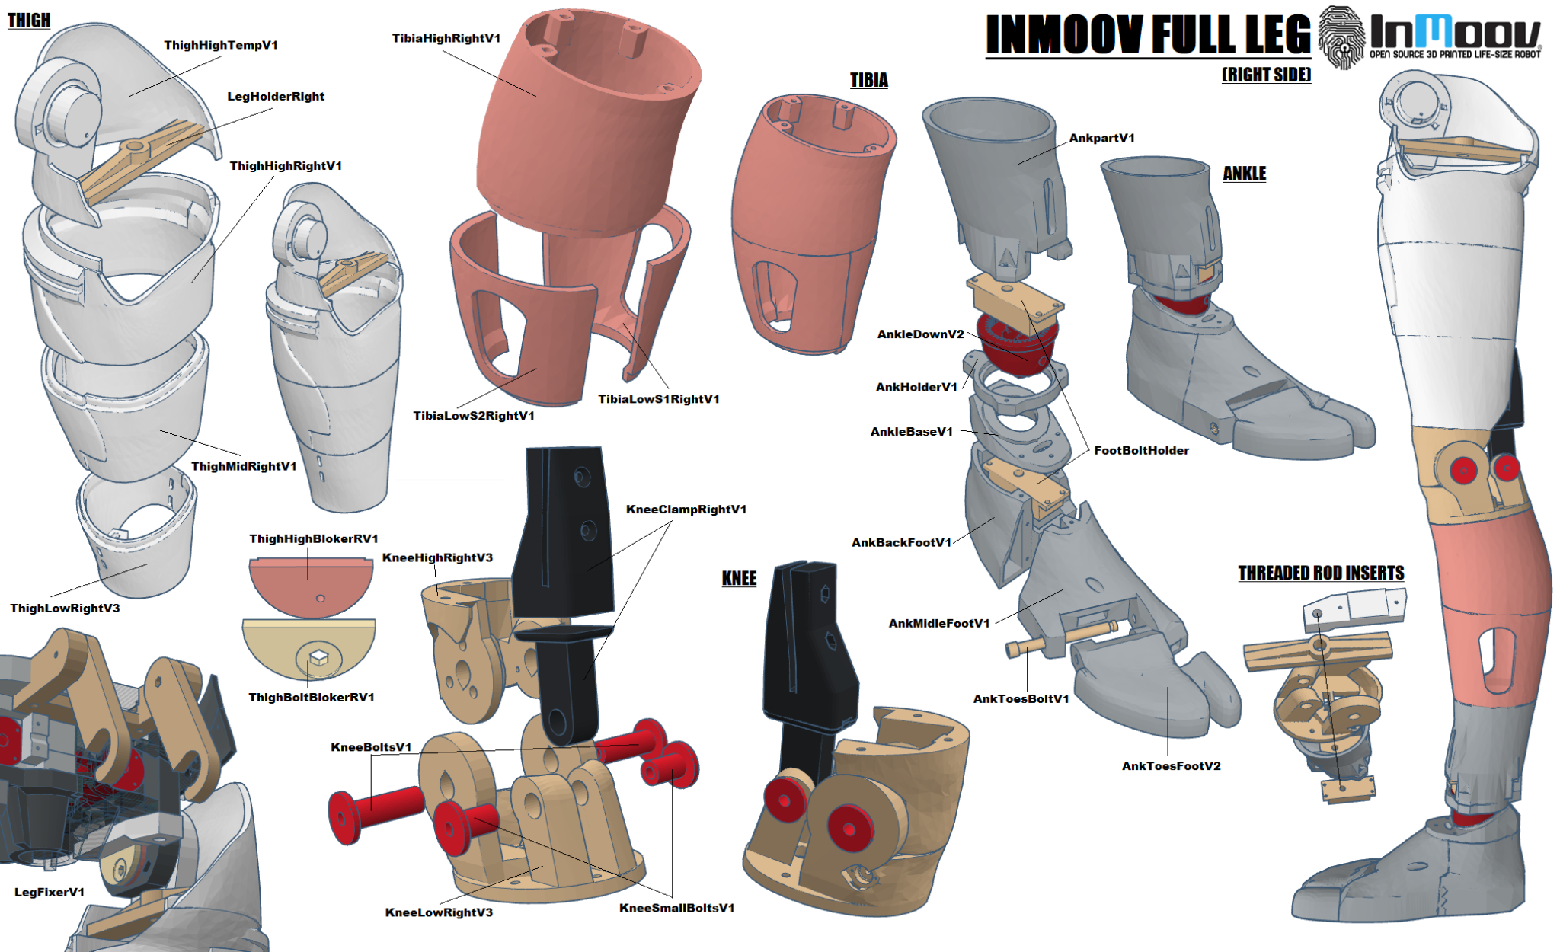

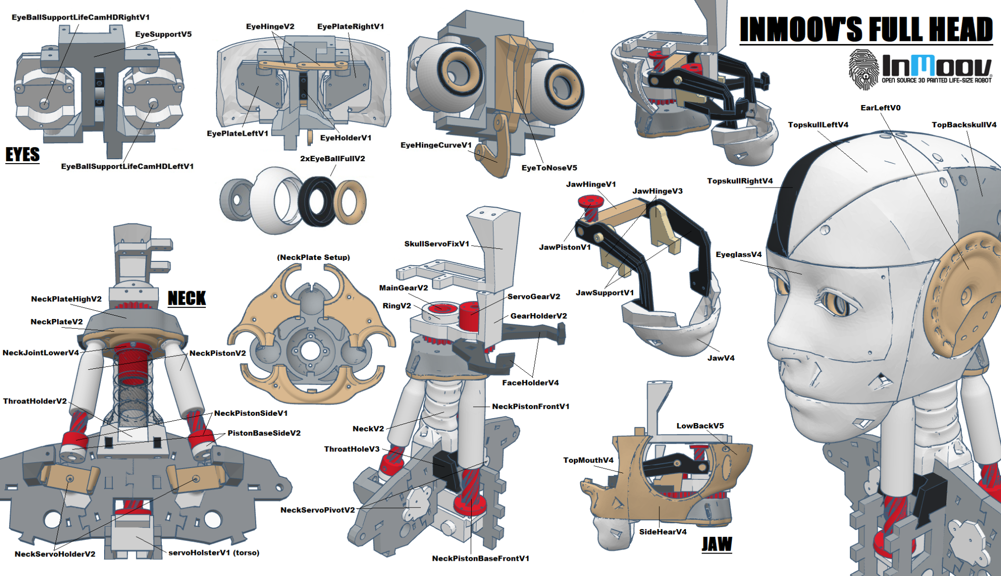

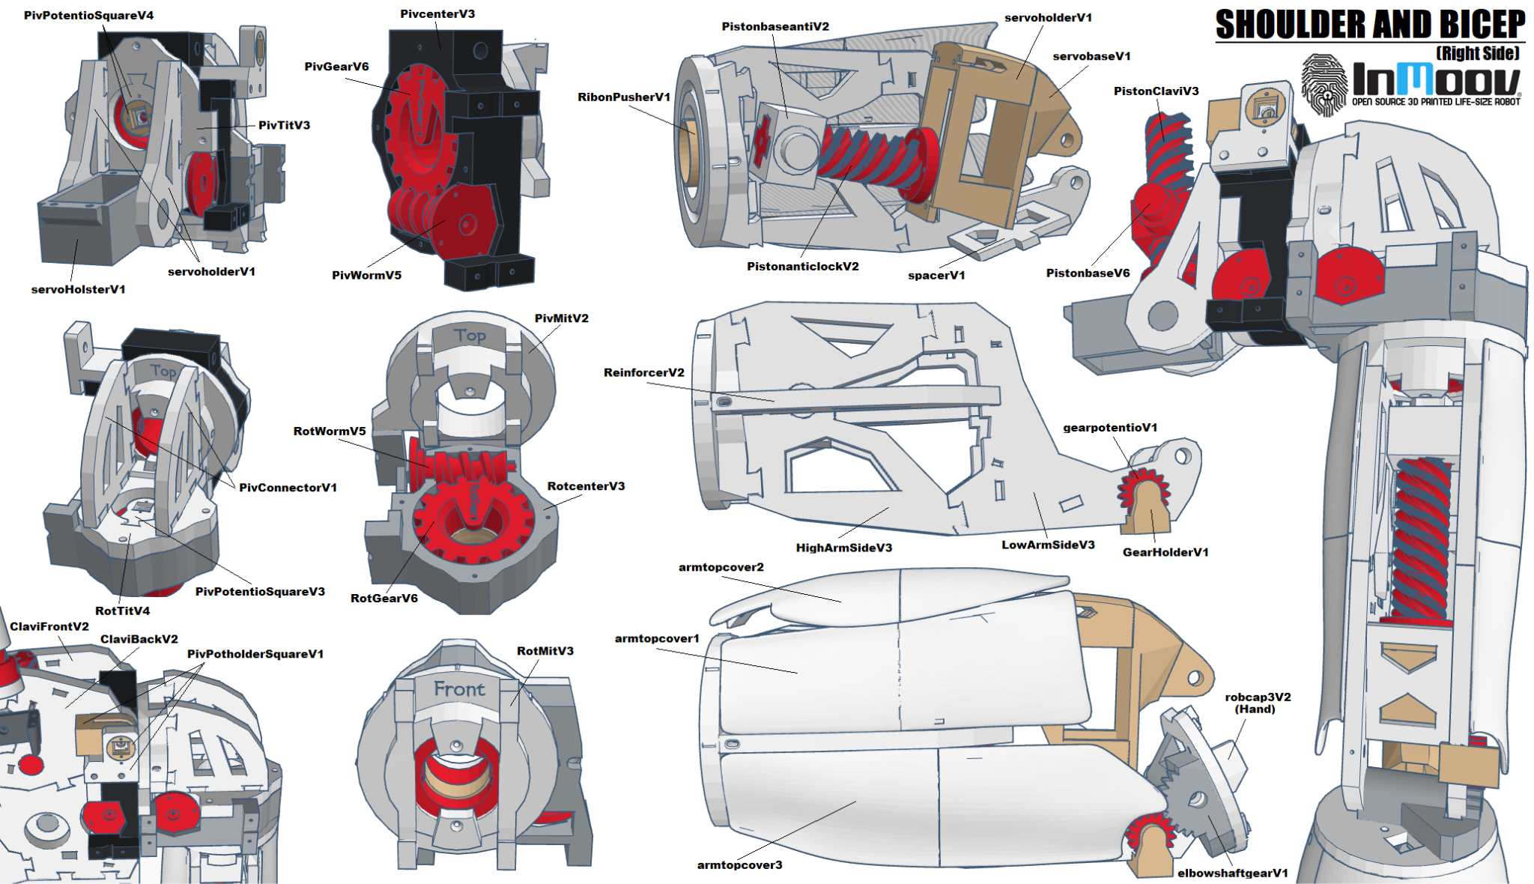

# 

# Electronic Part

## Core Components

Cuza is controlled with the help of two Raspberry Pi 3Bs, one for controlling the head and AI responses, and one for controlling the hands. The motors of the down plate are controlled with an Arduino Mega, connected to two motors and communicating with a web server.

Each Raspberry is connected via bluetooth to Mega Arduino boards with shields for controlling motors.

## Servomotors

The Head uses:

* 2x MG995 High-speeds 12kg servos, one for the jaw and one for the
* 2x sg90 micro servos, for the eyes, one vertical, one horizontal

Hands use:

* 1x Yunique, DS5160 7.4V 60KG for the left shoulder
* 2x MG995 High-speeds 12kg servos for the elbow

The Plates use:

* 2x Tank Motors 30Kg

## Input/Output Devices

The following devices are used for controlling the robot:

* BrainAccess Halo, developed by BrainAccess, for EEG transmission, connected via WiFi
* Meta Quest 2, developed by Meta, for VR access, connected via WiFi
* EMG sensor, connected via Serial
* A Logitech Webcamera, connected via Serial
* Hama Boomboxes, connected via Serial

# Robot Programming

All programming on Arduinos was written in c++ using Arduino IDE 2.0, meant for controlling the servos of the project.

## EEG reading

The EEG Band is connected via bluetooth to a python app for forwarding the message to a Node.js server, and then to be read by the Arduino Mega. By analyzing the change-in-voltage patterns emerging from watching flashing patterns on a screen, at distinct intervals program recognizes which direction the user is thinking about and sends a code to the server to detect it.

## AI Chatting/Translating

The AI Chatting app is built with python, using the API of OpenAI for answering questions, the speech-recognition import for text-to-speech, and pysx3 for speech recognition. Google speech recognition and speaking powers the robotic voice of Cuza.

## VR Application

The VR application is built with Unity, and uses the VrArmIK addon for calculating the Inverse Kinematics of the arms. Afterwards, the rotations of the arms are transmitted to a Node.js server to be received by the arm-controlling Raspberry PI and then to the Arduinos responsible for turning the motors of the shoulders and elbows.

## Mobile App

The Mobile control app was built using Kotlin, and consists of buttons for controlling the wheels of the panel and for starting the translation and chatting functionality. The app uses the Socket.io library for server-side communication.

# 